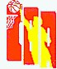
国 际 篮 球 联 合 会
记 录 表
A队___________________________________ B队_____________________________________
竞赛名称__________________ 日期_______ 时间______ 主裁判员____________________________________
比赛序号No._____________ 地点___________________ 副裁判员1____________ 副裁判员2_____________
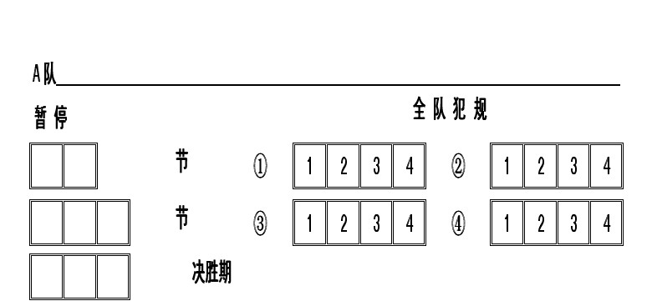 |  |  |  |  |  |  |  |  |  | 累积分
 |  |  |  |  |  |  |  |  |  | A |  | B |  | A |  | B |  | A |  | B |  | A |  | B
 |  |  |  |  |  |  |  |  |  |  | 1 | 1 |  |  | 41 | 41 |  |  | 81 | 81 |  |  | 121 | 121
 |  |  |  |  |  |  |  |  |  |  | 2 | 2 |  |  | 42 | 42 |  |  | 82 | 82 |  |  | 122 | 122
 |  |  |  |  |  |  |  |  |  |  | 3 | 3 |  |  | 43 | 43 |  |  | 83 | 83 |  |  | 123 | 123
证件号码 | 队员 | 号 | 上场队员 | 犯规 |  |  |  |  |  |  | 4 | 4 |  |  | 44 | 44 |  |  | 84 | 84 |  |  | 124 | 124
 |  |  |  | 1 | 2 | 3 | 4 | 5 |  |  | 5 | 5 |  |  | 45 | 45 |  |  | 85 | 85 |  |  | 125 | 125
 |  |  |  |  |  |  |  |  |  |  | 6 | 6 |  |  | 46 | 46 |  |  | 86 | 86 |  |  | 126 | 126
 |  |  |  |  |  |  |  |  |  |  | 7 | 7 |  |  | 47 | 47 |  |  | 87 | 87 |  |  | 127 | 127
 |  |  |  |  |  |  |  |  |  |  | 8 | 8 |  |  | 48 | 48 |  |  | 88 | 88 |  |  | 128 | 128
 |  |  |  |  |  |  |  |  |  |  | 9 | 9 |  |  | 49 | 49 |  |  | 89 | 89 |  |  | 129 | 129
 |  |  |  |  |  |  |  |  |  |  | 10 | 10 |  |  | 50 | 50 |  |  | 90 | 90 |  |  | 130 | 130
 |  |  |  |  |  |  |  |  |  |  | 11 | 11 |  |  | 51 | 51 |  |  | 91 | 91 |  |  | 131 | 131
 |  |  |  |  |  |  |  |  |  |  | 12 | 12 |  |  | 52 | 52 |  |  | 92 | 92 |  |  | 132 | 132
 |  |  |  |  |  |  |  |  |  |  | 13 | 13 |  |  | 53 | 53 |  |  | 93 | 93 |  |  | 133 | 133
 |  |  |  |  |  |  |  |  |  |  | 14 | 14 |  |  | 54 | 54 |  |  | 94 | 94 |  |  | 134 | 134
 |  |  |  |  |  |  |  |  |  |  | 15 | 15 |  |  | 55 | 55 |  |  | 95 | 95 |  |  | 135 | 135
 |  |  |  |  |  |  |  |  |  |  | 16 | 16 |  |  | 56 | 56 |  |  | 96 | 96 |  |  | 136 | 136
 |  |  |  |  |  |  |  |  |  |  | 17 | 17 |  |  | 57 | 57 |  |  | 97 | 97 |  |  | 137 | 137
教练员 |  |  |  |  |  |  |  |  |  |  | 18 | 18 |  |  | 58 | 58 |  |  | 98 | 98 |  |  | 138 | 138
助理教练员 |  |  |  |  |  |  |  |  |  |  | 19 | 19 |  |  | 59 | 59 |  |  | 99 | 99 |  |  | 139 | 139
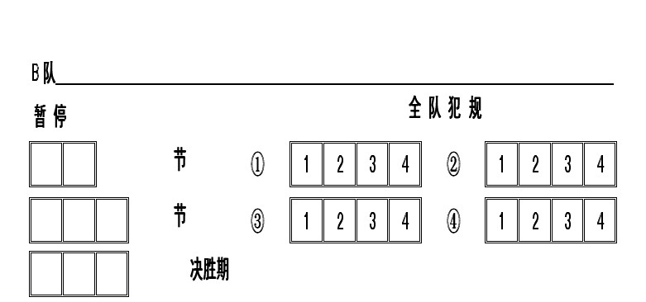 |  |  |  |  |  |  |  |  |  |  | 20 | 20 |  |  | 60 | 60 |  |  | 100 | 100 |  |  | 140 | 140
 |  |  |  |  |  |  |  |  |  |  | 21 | 21 |  |  | 61 | 61 |  |  | 101 | 101 |  |  | 141 | 141
 |  |  |  |  |  |  |  |  |  |  | 22 | 22 |  |  | 62 | 62 |  |  | 102 | 102 |  |  | 142 | 142
 |  |  |  |  |  |  |  |  |  |  | 23 | 23 |  |  | 63 | 63 |  |  | 103 | 103 |  |  | 143 | 143
 |  |  |  |  |  |  |  |  |  |  | 24 | 24 |  |  | 64 | 64 |  |  | 104 | 104 |  |  | 144 | 144
证件号码 | 队员 | 号 | 上场队员 | 犯规 |  |  |  |  |  |  | 25 | 25 |  |  | 65 | 65 |  |  | 105 | 105 |  |  | 145 | 145
 |  |  |  | 1 | 2 | 3 | 4 | 5 |  |  | 26 | 26 |  |  | 66 | 66 |  |  | 106 | 106 |  |  | 146 | 146
 |  |  |  |  |  |  |  |  |  |  | 27 | 27 |  |  | 67 | 67 |  |  | 107 | 107 |  |  | 147 | 147
 |  |  |  |  |  |  |  |  |  |  | 28 | 28 |  |  | 68 | 68 |  |  | 108 | 108 |  |  | 148 | 148
 |  |  |  |  |  |  |  |  |  |  | 29 | 29 |  |  | 69 | 69 |  |  | 109 | 109 |  |  | 149 | 149
 |  |  |  |  |  |  |  |  |  |  | 30 | 30 |  |  | 70 | 70 |  |  | 110 | 110 |  |  | 150 | 150
 |  |  |  |  |  |  |  |  |  |  | 31 | 31 |  |  | 71 | 71 |  |  | 111 | 111 |  |  | 151 | 151
 |  |  |  |  |  |  |  |  |  |  | 32 | 32 |  |  | 72 | 72 |  |  | 112 | 112 |  |  | 152 | 152
 |  |  |  |  |  |  |  |  |  |  | 33 | 33 |  |  | 73 | 73 |  |  | 113 | 113 |  |  | 153 | 153
 |  |  |  |  |  |  |  |  |  |  | 34 | 34 |  |  | 74 | 74 |  |  | 114 | 114 |  |  | 154 | 154
 |  |  |  |  |  |  |  |  |  |  | 35 | 35 |  |  | 75 | 75 |  |  | 115 | 115 |  |  | 155 | 155
 |  |  |  |  |  |  |  |  |  |  | 36 | 36 |  |  | 76 | 76 |  |  | 116 | 116 |  |  | 156 | 156
 |  |  |  |  |  |  |  |  |  |  | 37 | 37 |  |  | 77 | 77 |  |  | 117 | 117 |  |  | 157 | 157
 |  |  |  |  |  |  |  |  |  |  | 38 | 38 |  |  | 78 | 78 |  |  | 118 | 118 |  |  | 158 | 158
教练员 |  |  |  |  |  |  |  |  |  |  | 39 | 39 |  |  | 79 | 79 |  |  | 119 | 119 |  |  | 159 | 159
助理教练员 |  |  |  |  |  |  |  |  |  |  | 40 | 40 |  |  | 80 | 80 |  |  | 120 | 120 |  |  | 160 | 160
记录员 _________________________  助理记录员 _________________________  计时员 _________________________  24秒钟计时员 _________________________ |  |  |  |  |  |  |  |  | 得分 |  |  |  |  | 节 ① A_____ B_____
 |  |  |  |  |  |  |  |  |  |  |  |  |  | 节 ② A_____ B_____
 |  |  |  |  |  |  |  |  |  |  |  |  |  | 节 ③ A_____ B_____
 |  |  |  |  |  |  |  |  |  |  |  |  |  | 节 ④ A_____ B_____
 |  |  |  |  |  |  |  |  |  |  |  |  |  | 决胜期 A_____ B_____
主裁判员_____________________________________ |  |  |  |  |  |  |  |  | 最后比分 A队_____ B队_____  胜队__________________________
副裁判员1____________ 副裁判员2_____________
球队抗议队长签名__________________________________

